InstantMessenger
A Secure End-to-End Encrypted Android Messaging Application

Final Project Report
Computer Networks (CN)

Submitted By

Name | Roll Number
Ayan Bin Moeen | 23I-0124
Zaid Bin Naveed | 23K-0028

FAST School of Computing
National University of Computer & Emerging Sciences
Karachi Campus
2024

1. Motivation
In today's hyper-connected world, digital communication has become the backbone of personal and professional interaction. Yet the majority of widely used messaging platforms store messages on centralized servers, leaving user data vulnerable to breaches, unauthorized surveillance, and data monetization. The question of who can read your private conversations is no longer hypothetical — it is a real and present concern for billions of users worldwide.
This project was born out of a desire to understand, from first principles, how secure communication works — and to build something that demonstrates those principles in a real, functional application. As Computer Networks students, we wanted to go beyond theory and implement the very cryptographic protocols that protect modern communications: RSA public-key infrastructure, AES-GCM symmetric encryption, and Firebase Cloud Messaging for real-time delivery. The result is InstantMessenger — a fully functional Android messaging app with true end-to-end encryption, where private keys never leave the user's device.

2. Overview
InstantMessenger is a real-time Android messaging application that implements end-to-end encryption (E2EE) using a hybrid RSA + AES-GCM cryptographic scheme. The application supports text messaging, image sharing, push notifications, read receipts, online/offline status indicators, and message delivery statuses — all the features of a modern messaging platform — while ensuring that message content is cryptographically protected from anyone other than the intended recipient, including the server infrastructure itself.
The application uses Google Firebase for its backend infrastructure: Firestore for real-time database synchronization, Firebase Authentication for user identity management, and Firebase Cloud Messaging (FCM) v1 API alongside OneSignal for push notification delivery. Cloudinary is used for image hosting. The encryption layer is implemented entirely on-device using Android's standard Java cryptography libraries — no third-party encryption library is required.

3. Significance of the Project
The significance of this project spans both academic and practical dimensions. From an academic standpoint, it demonstrates a comprehensive application of Computer Networks concepts including: network communication protocols, public key infrastructure (PKI), symmetric and asymmetric cryptography, real-time data synchronization over TCP/IP, and push notification delivery systems. From a practical standpoint, the application addresses a genuine gap in user privacy — the ability to communicate privately without trusting a third-party server.
The difficulty of implementing E2EE correctly is well-documented — even large technology companies have shipped flawed implementations. Our project tackles key management, key synchronization, forward secrecy considerations, and graceful handling of key mismatches, making it a technically challenging and academically valuable endeavor.

4. Description of the Project
The problem this project solves is the insecurity of centralized message storage. When messages are stored on a server in plaintext or with server-side encryption, anyone with access to that server — including the service provider, attackers, or government agencies — can read those messages. End-to-end encryption solves this by ensuring that encryption and decryption happen exclusively on the communicating devices, with keys that only the participants possess.
InstantMessenger implements this through a hybrid encryption scheme. When a user registers, a 2048-bit RSA key pair is generated on their device. The public key is uploaded to Firestore; the private key never leaves the device and is stored in Android SharedPreferences. When User A sends a message to User B, the following process occurs:
- A random 256-bit AES key is generated for this specific message.
- The message is encrypted using AES/GCM/NoPadding with a randomly generated 12-byte IV, providing both confidentiality and integrity.
- The AES key is encrypted twice using RSA/ECB/PKCS1Padding: once with User B's public key (so B can decrypt), and once with User A's own public key (so A can re-read their own sent messages).
- All four components — encKeyForSender, encKeyForRecipient, IV, and ciphertext — are stored as separate fields in Firestore.
- Upon receiving, each user attempts to decrypt using their own private key, trying the sender slot first, then the recipient slot.

The scope of the project covers one-to-one messaging only. Group chats, voice/video calls, and file transfer beyond images are outside the current scope. The application is designed specifically for Android and uses Kotlin as its programming language.

5. Background of the Project
End-to-end encryption in messaging has its roots in Phil Zimmermann's PGP (Pretty Good Privacy) system from 1991, which used a similar hybrid RSA + symmetric key approach. Modern messaging applications like WhatsApp (which uses the Signal Protocol), Signal, and iMessage implement variations of this concept. The Signal Protocol, developed by Moxie Marlinspike, adds forward secrecy through the Double Ratchet Algorithm, which rotates keys with every message — a feature beyond the scope of this implementation but a natural next step.
The cryptographic primitives used in this project are industry-standard. RSA-2048 provides asymmetric encryption for key exchange. AES-256-GCM provides authenticated symmetric encryption for message content, with the GCM (Galois/Counter Mode) providing built-in message authentication codes (MACs) that detect tampering. Firebase Firestore provides real-time NoSQL database synchronization using WebSocket connections over HTTPS.

Project Category
This is a Product-based project. It results in a fully functional Android application that can be installed and used on real devices, demonstrating applied Computer Networks concepts in a tangible, user-facing product.

6. Features / Scope / Modules

6.1 End-to-End Encryption (E2EE)
Every text message is encrypted using a hybrid RSA-2048 + AES-256-GCM scheme before being stored in Firestore. The private key is generated on-device at registration and never transmitted. A key synchronization mechanism detects and automatically resolves key mismatches caused by app reinstallation or data clearing, regenerating the key pair and updating Firestore transparently.

6.2 Real-Time Messaging
Messages are synchronized in real-time using Firestore's addSnapshotListener, which maintains a persistent WebSocket connection to Firebase servers. New messages appear instantly on both devices without polling. The application handles offline scenarios gracefully, marking messages as 'pending' when no network connection is available.

6.3 Push Notifications via FCM v1 API and OneSignal
Push notifications are delivered using a dual-provider approach. The Firebase Cloud Messaging (FCM) v1 API with OAuth 2.0 JWT authentication is used as the primary notification mechanism, implemented directly from the Android client using a background thread to generate JWTs and call the FCM REST API. OneSignal was integrated alongside FCM as a secondary provider because direct server-side FCM delivery requires a paid Firebase plan — OneSignal provides a free tier that covers this gap. Notifications are intelligently suppressed when the recipient already has the relevant chat open (tracked via an activeChatId field in Firestore), preventing redundant notifications. Notification taps deep-link directly to the relevant chat.

6.4 Message Delivery Status
Messages display delivery status indicators similar to WhatsApp: a clock icon for pending (offline), a single grey tick for sent (reached Firebase), double grey ticks for delivered, and double blue ticks for read. Status transitions are handled through Firestore field updates.

6.5 Online/Offline Status & Last Seen
Each user's online/offline status is tracked in real-time in Firestore. When a user is active, their status shows 'online'. When they go offline, a last seen timestamp is recorded and displayed as 'last seen at HH:MM AM/PM'. Status updates are driven by Android lifecycle callbacks.

6.6 Image Sharing
Users can share images from their device gallery. Images are uploaded to Cloudinary via its Android SDK and stored as URLs in Firestore. Received images are displayed inline in the chat and can be tapped to view fullscreen with pinch-to-zoom capability via the PhotoView library.

6.7 Unread Message Counter
The chat list screen displays unread message counts as green badges on each conversation. Counters are maintained per-user in Firestore and are reset to zero when the user opens the relevant chat. The counter is driven by server-side increments to ensure accuracy across devices.

6.8 In-Chat Message Sound
When a new message arrives while the user has the chat screen open (window focused), a soft notification sound plays through the media audio stream — similar to WhatsApp's in-app message sound. Duplicate sounds for the same message are prevented using a message ID tracking mechanism.

7. Project Planning
The project was developed over a period of approximately 10 days following an incremental development methodology, with each day targeting a specific set of features. Responsibilities were divided between the two team members as follows:

Day | Goal | Ayan Bin Moeen | Zaid Bin Naveed
1 | Firebase Setup & Auth | Firebase project setup, Auth config | Register/Login UI & flow
2 | Real-Time Chat Core | Firestore schema, chat ID logic | Message send/receive, RecyclerView
3 | Push Notifications | FCM v1 API, JWT auth, OneSignal integration | Notification tap deep-linking
4 | Message Status & Read Receipts | Status field logic (sent/delivered/read) | Tick UI in MessageAdapter
5 | Online Status & Last Seen | Status listener, lastSeen timestamp | Status display in toolbar
6 | Image Sharing | Cloudinary upload integration | ImageViewer with PhotoView
7 | Unread Counter & Badges | Firestore unread count logic | Badge UI in ChatAdapter
8 | E2EE — Key Generation | RSA key pair gen, KeyStorageHelper | Public key upload to Firestore
9 | E2EE — Encryption/Decryption | AES-GCM encrypt/decrypt, EncryptedPayload | Key sync, self-test, UI integration
10 | UI Polish & Bug Fixes | Dark theme, notch handling, themes.xml | Testing on both devices, final fixes

8. Project Feasibility

8.1 Technical Feasibility
The project is technically feasible using current technology. Android's Java Cryptography Architecture (JCA) provides built-in support for RSA and AES-GCM operations without requiring external libraries. Firebase provides a robust, scalable backend with generous free-tier limits. The primary technical risk was implementing E2EE correctly — specifically ensuring key consistency across devices and app reinstallations, which was addressed by implementing a key synchronization mechanism that validates the stored private key against the public key in Firestore and regenerates the key pair if a mismatch is detected.

8.2 Economic Feasibility
The project was developed at zero cost. Firebase Spark (free) plan provides sufficient Firestore reads/writes, Authentication, and Cloud Messaging for development and demonstration purposes. Cloudinary's free tier provides adequate image storage and bandwidth. Android Studio is freely available. The only hardware cost was the two Android smartphones used for testing, which were personally owned by the developers.

8.3 Schedule Feasibility
The project was completed within the allotted semester timeframe. The 10-day incremental development schedule allowed for focused progress on each feature area. The most time-intensive component was the E2EE implementation, which required multiple debugging iterations due to the complexity of key management and the subtlety of cryptographic errors. Despite this, the full feature set was delivered within the schedule.

9. Hardware and Software Requirements

9.1 Hardware Requirements
- Two Android smartphones running Android 8.0 (API 26) or higher
- Minimum 2GB RAM on target devices
- Internet connectivity (Wi-Fi or mobile data) on both devices
- Development machine: Windows/Mac/Linux PC with minimum 8GB RAM

9.2 Software Requirements
- Android Studio Hedgehog or later
- Kotlin 1.9+
- Android SDK — minimum API 26, target API 34
- Google Firebase (Firestore, Authentication, Cloud Messaging)
- Cloudinary Android SDK — image upload and hosting
- PhotoView library — fullscreen zoomable image viewer
- JJWT (Java JWT) library — JWT generation for FCM v1 OAuth
- OneSignal Android SDK — secondary push notification provider
- Java Cryptography Architecture (JCA) — built into Android SDK

10. Diagrammatic Representation of the Overall System
The following diagram illustrates the overall architecture of InstantMessenger, showing the interaction between the Android client, Firebase backend services, and Cloudinary:

Device A  (Sender)  RSA Private Key  (on-device only) | Firebase Firestore  Encrypted messages  Public keys  User status, chat metadata | Firebase FCM + OneSignal  Push notifications  v1 API + OAuth JWT | Device B  (Receiver)  RSA Private Key  (on-device only)
Cloudinary — Image Storage & CDN Delivery

Figure 1. Overall system architecture of InstantMessenger.

Message flow: (1) Sender fetches recipient’s public key from Firestore. (2) Sender encrypts AES key with both parties’ public keys and encrypts message content with AES-GCM. (3) Encrypted payload is stored in Firestore. (4) FCM v1 API and OneSignal deliver a push notification to the receiver. (5) Receiver fetches the encrypted payload from Firestore and decrypts using their private key stored on-device. At no point does the plaintext message leave the device unencrypted.

11. References
[1] Google Firebase Documentation, "Cloud Firestore," Google LLC, 2024. [Online]. Available: https://firebase.google.com/docs/firestore
[2] Google Firebase Documentation, "Firebase Cloud Messaging," Google LLC, 2024. [Online]. Available: https://firebase.google.com/docs/cloud-messaging
[3] National Institute of Standards and Technology, "Recommendation for Block Cipher Modes of Operation: Galois/Counter Mode (GCM) and GMAC," NIST Special Publication 800-38D, November 2007.
[4] R.L. Rivest, A. Shamir, L. Adleman, "A Method for Obtaining Digital Signatures and Public-Key Cryptosystems," Communications of the ACM, vol. 21, no. 2, pp. 120-126, February 1978.
[5] M. Marlinspike and T. Perrin, "The Double Ratchet Algorithm," Signal Foundation, November 2016. [Online]. Available: https://signal.org/docs/specifications/doubleratchet/
[6] Cloudinary Documentation, "Android SDK," Cloudinary Ltd., 2024. [Online]. Available: https://cloudinary.com/documentation/android_integration
[7] Android Developers, "Java Cryptography Architecture (JCA) Reference Guide," Google LLC, 2024. [Online]. Available: https://developer.android.com/reference/javax/crypto/Cipher
[8] P. Zimmermann, "The Official PGP User’s Guide," MIT Press, Cambridge, MA, 1995.
[9] OneSignal Documentation, "OneSignal Android SDK Setup," OneSignal Inc., 2024. [Online]. Available: https://documentation.onesignal.com/docs/android-sdk-setup

12. Working Demo Screenshots
The following screenshots demonstrate the fully functional InstantMessenger application running on real Android devices. The app showcases the complete user journey from registration and login through to real-time encrypted messaging and push notification delivery.
Figure 2. App icon showing unread message badge (3 unread messages)
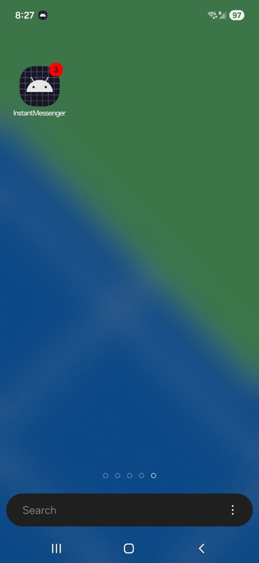
Figure 3. Push notifications delivered to lock screen showing sender name and message
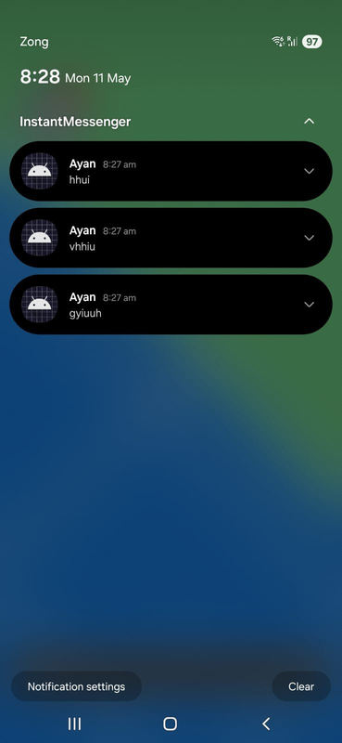
Figure 4. Chat list (home screen) showing conversations with unread count badge
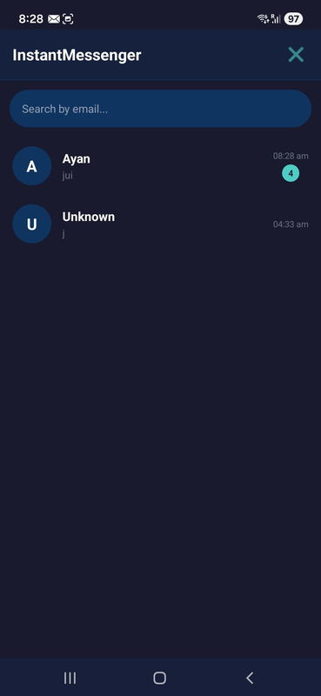
Figure 5. Chat screen showing received messages with timestamps
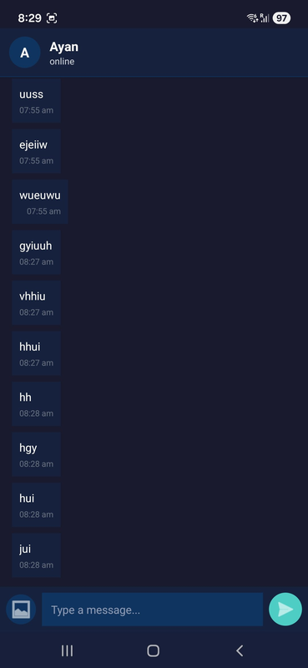
Figure 6. Chat screen showing sent messages with read receipts and delivery ticks
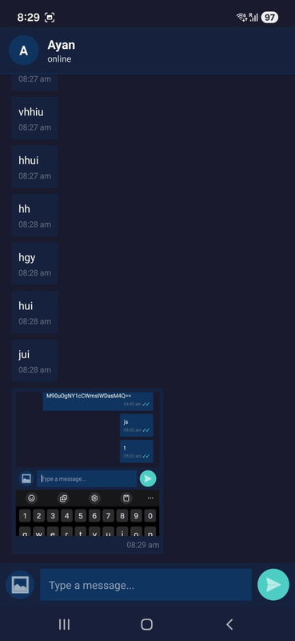
Figure 7. Login screen with dark theme UI
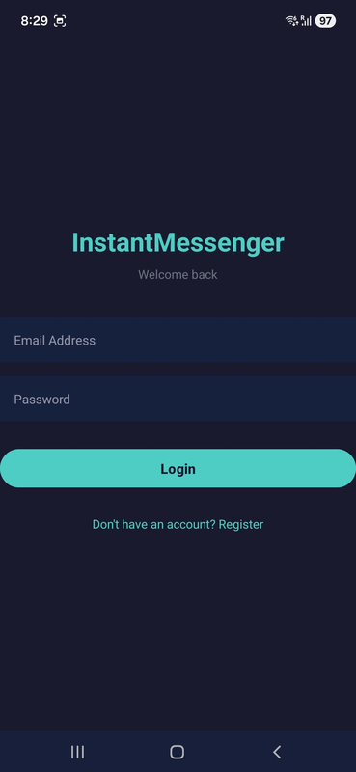
Figure 8. Registration screen for new user account creation
